Investor Onboarding
- Onboarding Process Flow

CapHive will enable the following activities for the investor onboarding process:

- Information collection through customised forms
- Information can be filled by the investor directly on the platform; OR
- Information can be filled by a distributor on behalf of the investor directly on the platform; OR
- Information can be bulk uploaded as an excel file by the fund

- Information validation / verification
- Information to be verified by the Fund using APIs (from Digio) for PAN verification, bank verification, CKYC
- AML through API from IDfy

- Document generation and execution
- The Investment agreement, placement memorandum and any other documents required for onboarding can be generated based on the template provided
- CapHive platform will generate these based on the information provided and also enable appending the specified KYC documents to the generated agreement(s)
- The generated documents may be sent for electronic stamping (if applicable) and e-signing. The fully executed document will be auto filed in the folder for the relevant commitment.
- Alternatively, the fund may download the generated documents for physical signatures.

- Requirements for set up

- Information for setting up the forms and templates on CapHive
- KYC Form to capture investor information - This should all include all details that you want to capture of the investor from a regulatory perspective and any other details that are required to be fetched in the agreements

- Draft contribution agreement template in word document - Please highlight all dynamic fields to be auto-populated from the platform

- Fund unit commercials - Please share unit wise commercials which need to be pulled in for the documents (if needed) in an excel file

- Digio Child account setup
The Digio child account is required for using e-sign and e-stamping APIs.
Digio will require: Entity details – Name, Brand Name, Email ID
Authorized signatory details – Name, Email, Mobile Number
These details will be filled in an onboarding form and sent to you for execution
Est TAT from Digio: 7-10 working days after receiving the completed form along with the documents.
List of KYC documents | Action required
Communication address | Please attach Electricity bill / Telephone bill/ Internet bill / rental agreement to support communication address ( Company seal and signature of authorised signatory sis must)
Registered address | Please attach Electricity bill / Telephone bill/ Internet bill / rental agreement to support registered address ( Company seal and signature of authorised signatory sis must)
Organization CIN / LLP IN | Attach CIN / LLP IN original copy, signed with company seal
Organization PAN | Attach CIN / LLP IN original copy, signed with company seal
Organization GSTIN | Attach 3 pager GSTR, signed with company seal
[If No-GST or Non-GST business] | Attach declaration letter to the same effect, signed with company seal on letterhead
Regulated/Affiliated entity: | Attach License/Affiliation document, signed with company seal
KYC of authorised signatory | Please provide Aadhar and PAN of authorised signatory with company seal and signature.

- Digio E-stamp requirements

- Quantity of stamp papers - (minimum 50 stamp papers)
Stamp Paper value - Rs. 500
First Party name -
State -
E-Stamp Article No. -
- Est TAT from Digio: 7-10 working days
- Alternatively, the stamp papers can be procured offline and bulk uploaded for each investor. The uploaded stamp paper will show as the first page of the generated agreement.

- Digio CKYC API
- FI Code of the fund
Note – the Investor / the fund will need to enter the PAN No, date of birth and the registered mobile number to receive the OTP for fetching the CKYC information

- AML
- The contract for activation of the AML API with IDfy attached in the email

Investor Onboarding - User Guide

Onboarding a new investor includes the following steps:
- Create a Stakeholder
- Add access rights for the user who can access the platform on behalf of the stakeholder (note this can be done a later point of time as well)
- Add the KYC or Investing Entity through which the investor will be making the commitment to the fund. There can be multiple ‘Investing Entities’ linked to one stakeholder.
- Add the Commitment details in the Fund
- Generate the Commitment Agreement / other onboarding related documents and send for electronic signatures

- Create a stakeholder

- Stakeholders can be created individually through the UI or in case of multiple stakeholders through a bulk excel upload template

- Adding individually through the UI
- Name, Category and Primary email (unique identifier on the platform) are mandatory fields needed for adding a new stakeholder
- Stakeholder name could be a family / investing group which has multiple investing entities mapped to it. (this can be done through the KYCs module eg. Stakeholder ABC with investing entities ABC Inc, Mr B and Mrs C mapped to it)
- Other fields are optional
- Tags help identify the stakeholders easily later for co-invests etc.
- In case there are any additional details you wish to track for a stakeholder, these can be added through a ‘Custom Field’ which can be a additional column in the excel bulk upload or through adding a Custom Field through the menu under the Home icon on top right of the screen.

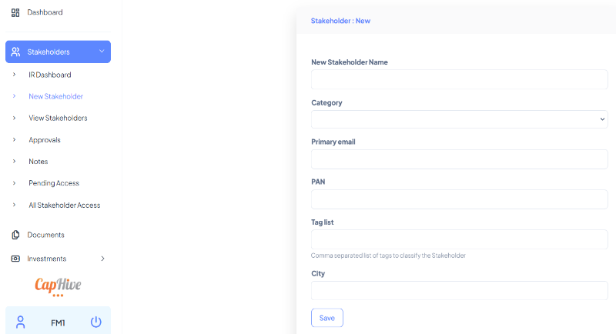

- Bulk upload

- Stakeholders >> View Stakeholders >> Actions >> Upload
- Fill in the relevant details in the below excel template and upload on the platform. Refer the notes included in the headers

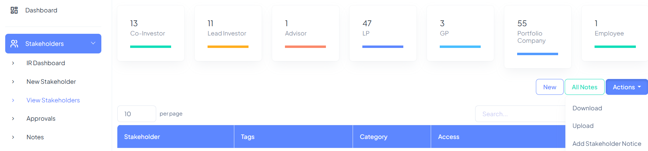

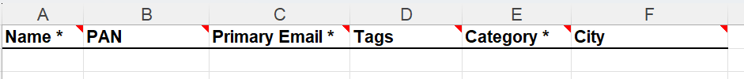

- Add Stakeholder Users (giving access to the users of Investors)

- Once the stakeholders are created on the platform add their respective users either directly on the platform or through an upload template for multiple stakeholders together

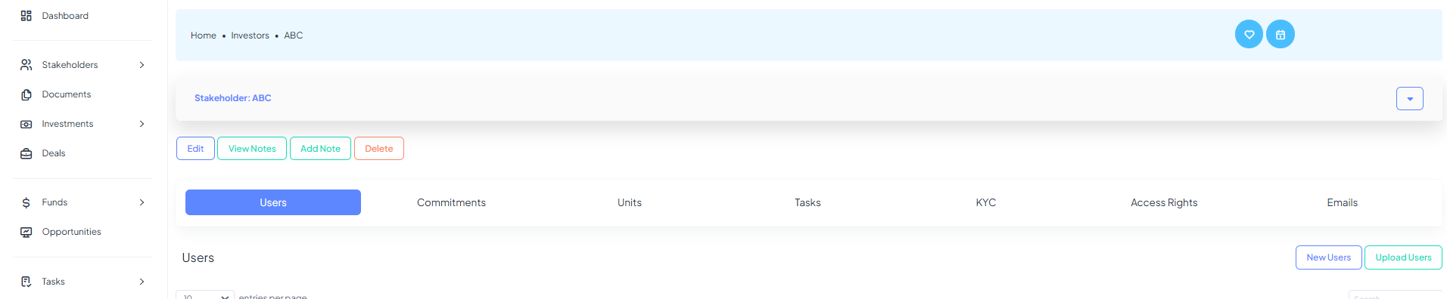

- Fill in the relevant details in the below excel template and upload on the platform. Refer the notes included in the headers

Notes:
- Mapping the correct Email: Ensure the email address is mapped to the correct "stakeholder" for proper permissions.
- Add Users: Multiple users can be added for each stakeholder.
- User Login: Each user will get a login with full access to the stakeholder's account. Contact CapHive support for detailed access control.
- Advisor Route: To map the same email to different users, use the advisor route. Connect with support@caphive.com for assistance.
- CC: Add email(s) in the 'cc' box as a comma-separated list to mark them as 'cc' on all stakeholder notifications. Users added in ‘cc’ will not be able to log onto the CapHive platform, but will me marked as cc on all emails sent to the user.
- Specific Fund CC: Incase the 'cc' needs to be for communications with respect to a specific fund, do not include 'cc' here. Instead create a custom 'cc' field for Commitment for that fund.

- Add KYCs or Investing Entities

- KYC or Investing entities are the legal entities making the specific investment.
- Multiple Investing Entities: Link multiple investing entities to one stakeholder; details of the investing entity are used in generating agreements/statements on the platform
- KYC may be added by the funds entity or for the investor or by a distributor.

- KYC details added by Funds
- For a specific stakeholder, go to the tab for KYC to view existing KYCs set up or to add a new one.
- Alternatively, access the KYC Module through the KYC button on the Dashboard
- Setup Custom Forms
        - A new form for details to be captured for an ‘Individual’ or a ‘Non-Individual’ need to be set up. This can be done by adding additional columns in the excel upload or by adding fields through the menu for ‘Customize Forms’, which can be accessed from the home icon on the top right
        - Adding new custom fields or editing exiting ones, will give the optionality for more advanced settings of the type of field (eg: text, number, file, select, etc) as well as ability to add conditional fields
Field settings
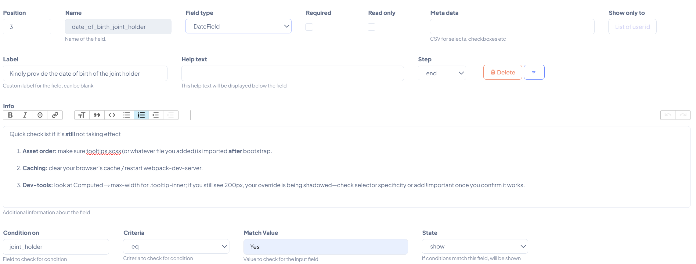
Conditional fields settings
Field name and help text visible on the form
Pop us messages for investor explanations

- Bulk Uploads: Multiple records can be uploaded in bulk though the link for ‘Upload KYC Details’. Please Upload separately for individual and non-individual investing entities to create unique forms with different custom fields
- Dashboard View: Stakeholder’s users can see all investments by different investing entities
- Bulk KYC Documents Upload: In case of adding documents in bulk for multiple KYCs, use the 'Upload KYC Documents' option with a zip file and an index file as per sample. Refer to the guide on Bulk Documetnsy upload for more details on setting up the index for the bulk upload which helps maps documents to the correct place.
- Customized Rules: Set up customized rules for validation of documents, extraction of data from documents, etc. from investors (eg : extract KYC data like PAN, address, bank account etc. from CML)
- API validations: CapHive integrates a range of third party APIs for validations or verification of information like PAN, Bank account (including penny drop features), CKYC, AML etc. Please speak the CapHive support team for more information on these.
- Verification: A completed KYC needs to be Verified by a user with Approver role. Once Verified, the form is locked for further editing and the KYC can then be used for generating documents for the linked commitment etc. Note, in case the KYC is not verified, the document will not be generated.
The button for Verify will only be visible if the user has the Approver role.

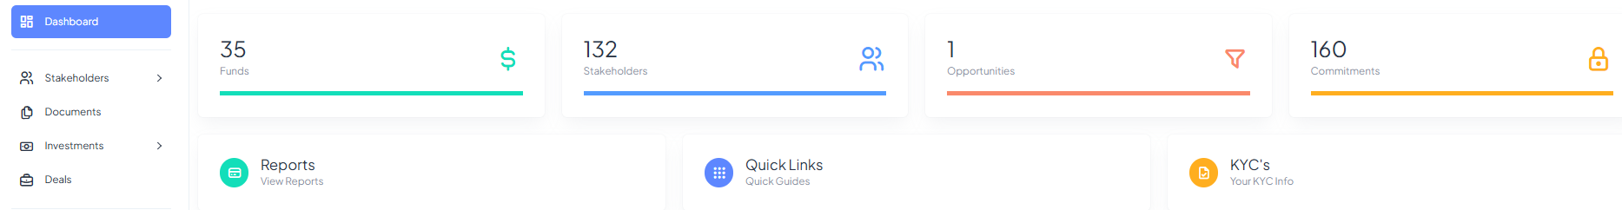

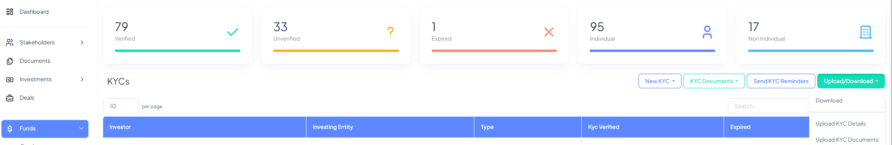

- KYC details added by Investor

- Under the tab for the relevant stakeholder, click on the option for send link to stakeholder to send the link requesting for the stakeholder to update the form. Any specific instructions along wth any templates of declarations needed to be signed by the investor can be added in the relevant Custom Notification for new KYC request.
- For sending the link to multiple stakeholders, please use the bulk KYC upload option (note separately for individuals or non-individuals) and in the column for ‘Send KYC Form to User’ select Yes and upload.
- The user will receive a personalised link which will take them directly to the form (after logging in).
- The user will need to fill all the details as per the instructions mentioned in the custom fields form and then Save the form
- The Fund users will receive a notification on the detail filled by the user to be able to log in and verify.

- Adding Commitments for a fund

- Commitments by investors can be created either individually for each stakeholder directly on the platform (through the button for New Commitment) or in bulk through an excel upload template for multiple stakeholders (Commitments >> Upload)

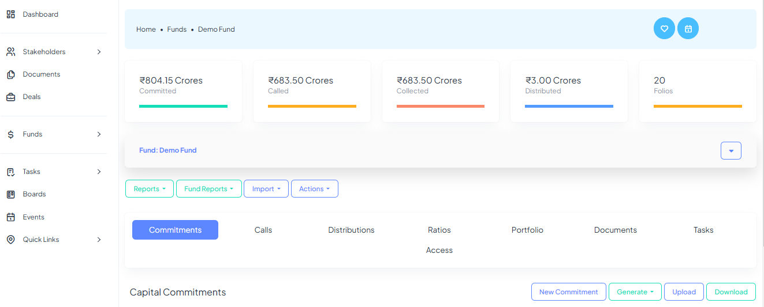

- Fill in the relevant details by referring the description of the field provided just below the field in grey font on the platform
- If a stakeholder has multiple investing entities select the appropriate investing entity and add the unique folio id for each commitment. By default, the last updated KYC will be linked with a commitment.
- Refer the notes included in the headers of the excel upload template if adding commitments in bulk
- Additional details can be captured in the commitments by adding additional columns in the excel upload template as custom fields
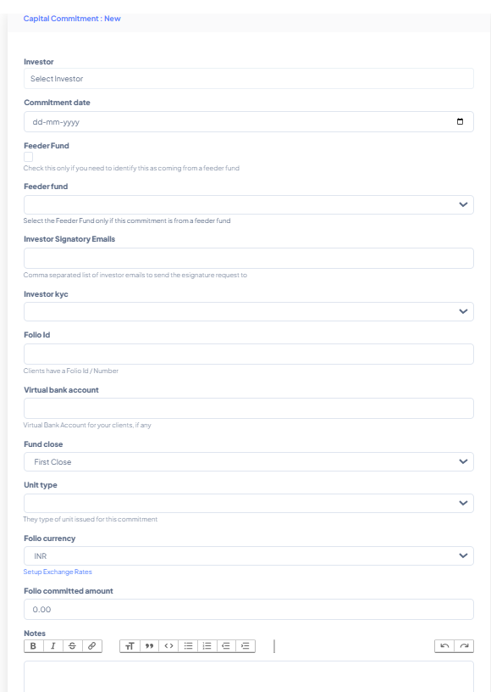

- Any adjustments (eg: top-ups, arrears adjustments, exchange rate changes) to the commitment can be done through the ‘Adjustments’ tab inside the respective commitment. Commitment amount cannot be edited (except in case of a commitment set up with a ‘0’ value). Any edits will need to be done though the Adjustments tab.

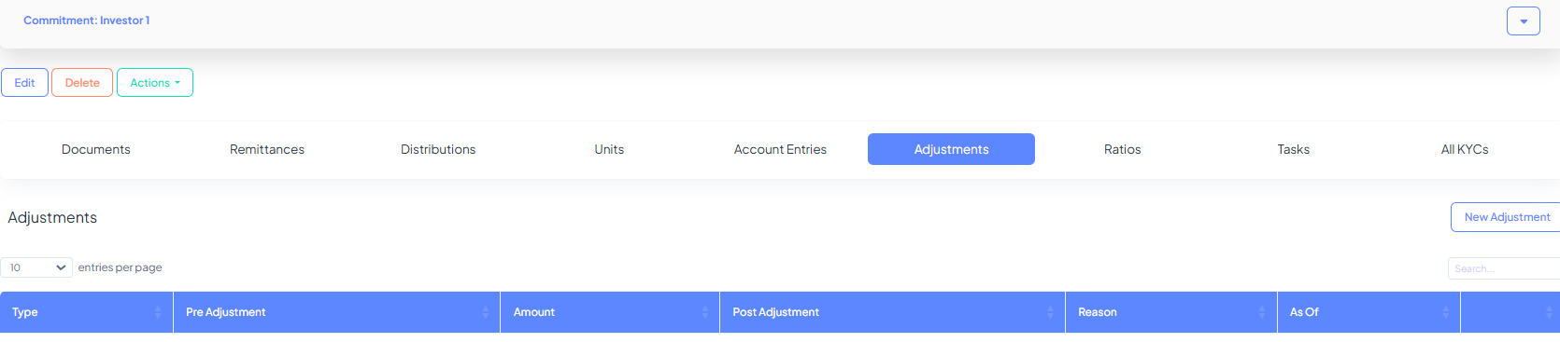

- Generating Commitment Agreements
CapHive can generate highly customised agreements which can pool in fields from the specific commitment, the linked KYC and the relevant fund unit settings to generate the agreement.

  - Template for Commitment Agreements

- A Commitment Agreement Template (word file) should be added to the platform before generating the Commitment Agreements
- The Template consisting of dynamic fields to capture the details unique to each stakeholder when generated on the platform would be set up by the CapHive support team
- To upload the template, go to Actions >> Misc >> New Template
- To Edit a template, find the relevant template in the ‘Documents’ tab for the fund, and download the same. The static portion of the template can be edited by the user at any point of time by downloading the template from the platform and reuploading the edited version, into the same Document through clicking on Edit.
- Template also provides the option to add setting for e-Sign and e-Stamp. Please contact CapHive support for more details setting up the e-Sign and e-Stamp.

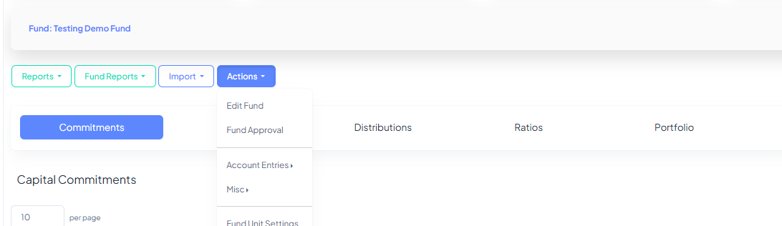

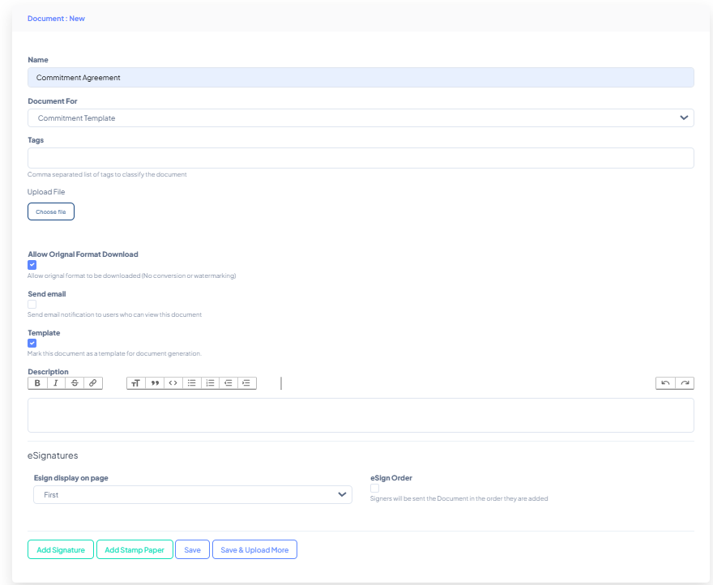

  - Generating Commitment Agreements

- A commitment agreement can be generated either for a single stakeholder or together for all the stakeholders
- Before generating the agreement ensure that the KYCs are verified on the platform
- To generate the agreement for a specific commitment, go inside the respective commitment and Actions >> Generate Commitment Agreement
- CapHive’s strong document generator also provides the option to append specific documents from the KYC such as address proof, declarations etc, which can be included in the final document set sent for e-sign. CapHive support team will assist in setting up the same.
- Note – Please check the formatting: Depending on how the format for numbering and paragraphs was set up for the base template, these can change at the time of generating the pdf. Unfortunately, this is a word to pdf conversion issue and not something we can control. Hence you are requested to carefully review the formatting of the generated document, in particular the first time this is generated.

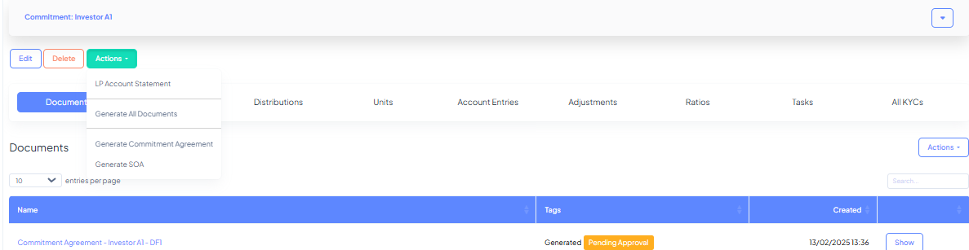

- To generate the CA for all commitments together go to Commitments >> Generate >> Commitment Agreement
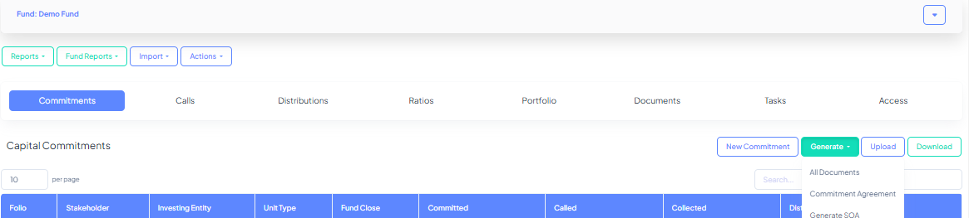

- The generated agreement will appear inside the respective commitment
- The user with ‘approver’ role will approve the agreement post which it can be sent to the signatories for e-sign.
The status of the documents sent for e-sign can be check through the report for e-signatures, accessed through the Reports menu for the fund.
- Once the document is fully signed, it will be auto-pulled back into the platform and saved inside the relevant commitment.

FAQs on onboarding:

- Getting an error while adding a stakeholder user:
  - As a security feature, we do not let one user be associated with multiple Stakeholders. Hence in case you are trying to add the same email address for multiple stakeholders you could consider one of the following options:
    - Use a different email address for difference stakeholders
    - Keep onely one stakeholder and add multiple Investing Entities (KYCs) under the same. This was the same email address when logging in can view commitments etc associated across multiple KYCs by linked to the same stakeholder
  - It may be possible that the same email address is associated with a different stakeholder for a separate client. For such cases, you will need to ask CapHive support to help with resolving the issue.

- I’m not giving access to a stakeholder, then why do you need an email address?
  - Email address when creating a stakeholder is used as the unique identifier for creating an account. This email address is not used for any notifications or providing access.
  - User access will only be provided if you add a stakeholder user and ‘Approve’ the same.

- Investor is not able to view a commitment:
  - For any issues related to user access, please check the following:
    - Whether the Stakeholder user has been added with the correct email address and the same is ‘Approved’
    - Check if the User is added in the access right for the respective fund. This can be checked under the tab for ‘Access’ inside the respective fund.
By default, when a stakeholder’s commitment is added to a fund, the access for the same is provided. However in case of any manual addition at a later time or specific deletion of access right it may not be visible.
    - If the issue still persists, please contact CapHive support.

- Updating details for a KYC
  - To update any details for a KYC, you can click on edit inside the relevant KYC and make the change and save. In case the KYC is verified, then the same will first need to be unverified
  - To ask the Investor to log an make a change, you can send the link for an unverified KYC.
  - For making changes in bulk, please download the excel file KYC details - these will be presented in two separate sheets for Individual and Non-Individual. You can edit the relevant fields and upload it back to the platform, keeping on the edited field and the unique identifier ie/ Stakeholder name and Investing Entity along with the column for ‘Update Only’ marked as Yes.
    - This will overwrite all the fields included as columns (except for the name). So please carefully review the file prior to uploading.
    - In case Update Only is not marked as Yes, then the record shall not be updated and an appropriate error message will be included in the results file.

- Commitment in a different currency:
  - CapHive supports multi-currency fund vehicles. To enable the same, CapHive support will need to enable the relevant currencies for your fund, post which at the time of adding the commitment, you can select the relevant currency applicable for the specific commitments (called the ‘Folio Currency’).
  - Note, the platform will autopick the last exchange rate applicable to the relevant date for the conversion, so please ensure the updated exchange rate has been added under the exchange rates section (accessible through the home icon on the top right of your screen) or inside the relevant upload file which will have hidden columns for advance uses cases relating to Multi-currency frameworks. Please discuss this with CapHive to familiarize yourself on the same.

- Not getting the button to Generate Commitment Agreement:
  - The commitment needs to have a verified KYC linked with it to be able to generate documents. Hence please check if a KYC has been added for the stakeholder and linked to the respective commitment and that the KYC has been Verified by an Approver.

- Specifying the order for the Signatories for e-signatures
  - At the time of setting the e-sign, you can specify the order in which the request will be sent.

- Reminders for e-signatures:
  - At the time of the setup for e-sign, you can specify the frequency of auto reminders for those who’ve not yet signed
  - Ad-hoc reminders cannot currently be triggered through the CapHive app, since there is no API available for now. Hence, you’ll need to log onto the e-sign provider’s application and trigger the reminder.

